**Advanced Data Science with IBM Specialization**

### Capstone Project by

Saifullah Aftab

Powered by



# Stakeholder Presentation

* **Problem Statement**
* **Dataset**
* **Use cases**
* **The Solution**

**Predict average spend on Food & Beverages**

**by a holiday resort member**

**Problem Statement**

**The company, the most preferred holiday resort chain in India** makes significant revenue from Food and Beverages (F&B) sales in their resorts. The members of the company club are offered a wide variety of items in either buffet or restaurant form.

##### Given the information related to resort, club member, reservation etc. the task is to predict average spend per room night on food and beverages for each reservation.

**This is a regression problem, and we will train a machine learning model on the provided data to give the predictions.**

The problem statement and data were provided by Club Mahindra at online hackathon DataOlympics in association with Analytics Vidhya:

https://datahack.analyticsvidhya.com/contest/club-mahindra-dataolympics/

**The Dataset**

##### Dataset info

**Number of variables** 24

**Number of observations** 314 424

**Total Missing (%)** 0.1%

##### Variable types Correlation Matrix

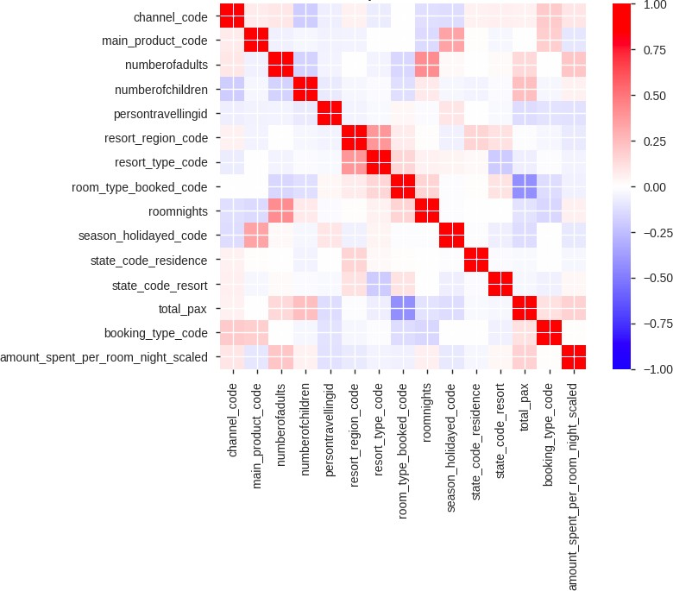**Categorical** 14

**Numeric** 11

**Date** 3

##### The variables have been anonymized:

* Categories (resort, state etc.) replaced with codes.
* Target variable (amount spent per room night) scaled.

##### The variables most correlated with the target:

* total_pax – total number of persons travelling
* numberofadults – number of adults travelling
* roomnights – number of room nights booked
* channel_code – different channels for booking
* state_code_resort – state in which resort is located

## The Use Case and the Solution

##### Following are some benefits the prediction model will bring:

* + Predicting the F&B spend of a member in a resort would help in improving the pre-sales during resort booking through web and mobile app.
  + Targeted campaigns to suit the member taste and preference of F&B.
  + Providing members in the resort with a customized experience and offers.
  + Help resort kitchen to plan the inventory and food quantity to be prepared in advance.

##### The data preparation and model training is conducted with Watson Studio. It uses Python, scikit learn and Jupyter technology. And deployed as a web-service with IBM Cloud.

**The solution architecture:**



Watson Studio



Docker

User

WEB UI Python

Jupyter

Scikit Learn

Flask REST API

Scikit Learn Model

# Technical Presentation

* + **Architectural choices**
  + **Data quality assessment, data pre-processing and feature engineering**
  + **Model performance indicators**
  + **Model algorithm**

**Architectural Choices**

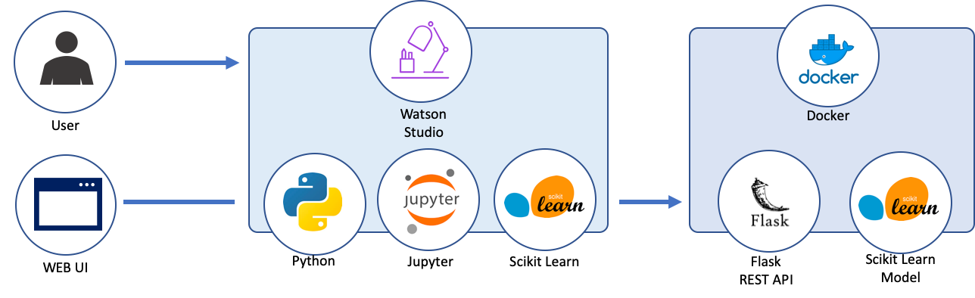

###### Core solution:

User provided CSV file uploaded to Watson Studio / IBM Object Storage.

Scikit-learn and Python in IBM Watson Studio with Jupyter notebooks:

* + - ETL; Data Exploration.
    - Feature Engineering; Model Definition and Validation.
    - Pipeline Notebook (takes raw CSV data and outputs the trained pipeline ready for deployment).

**Trained model is saved and deployed** as Flask REST API with Dash UI hosted at IBM Cloud.

###### Alternative solution:

* + - IBM Watson Studio Data refinery flow for raw data preparation.
    - Watson Machine Learning automatic modeling deployed as REST API web-service.

**Data Pre-Processing and Feature Engineering**

#### EDA

* + 24 variables and 314 424 observations (unique reservations).
  + 0.1% of total values are missing, 1.4% of missing values

in resort_type_code.

* + booking_date, checkin_date and checkout_date are date variables and should be parsed to datetime format at data loading stage.
  + memberid has high cardinality: 101 327 unique values.
  + numberofchildren has 77.4% of zero values.

#### Feature Engineering

* + **Date features**: booking_in_advance, days_stayed
  + Other features containing the information from the date (month, week, dayofweek, is_month_start etc.)
  + **Other features** (n_people etc.)

#### Pre-processing

* + Fill NA values with -1
  + Convert binary-type columns values to [0, 1]
  + OHE for categorical features
  + Scale the numerical features

## Model Performance Indicators

###### The model is evaluated on Root-Mean-Squared-Error (RMSE) between the predicted value and the observed amount spent.

The train/valid split performed based on memberid variable to prevent the data leak: we want to be able to predict the amount spent for the new members of hotels.

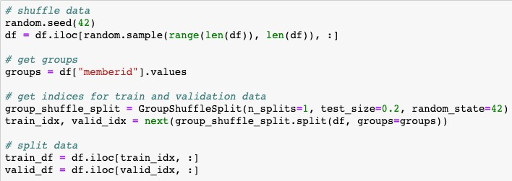

## Model Algorithm

The chosen model is **Linear Regression** with L2 regularization (Ridge Regression).

Model parameters are tuned on 5-fold cross validation stratified by memberid groups. The model performance is than validated with unseen data:

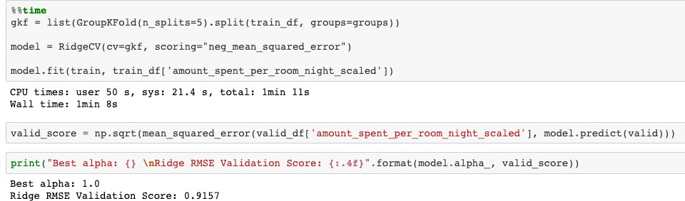

The model is trained and cross-validated in under 2 minutes with Watson Studio Lite plan (1 vCPU and 4 Gb RAM) and shows **RMSE score of 0.9157.**

## Model Deployment

**After model training and evaluation, we create separate Jupyter notebook with full pipeline:**

1. Loading data.
2. Pre-processing.
3. Create and save sklearn pipeline object to pickle file:
   * Choose columns
   * Transform columns
   * Train the model

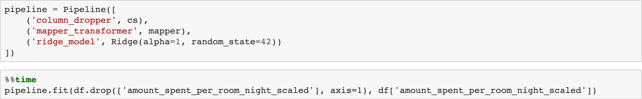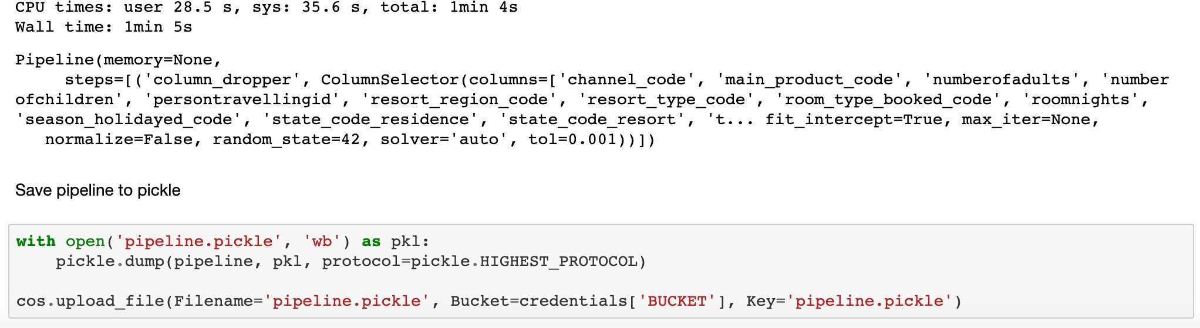

###### The fitted and trained pipeline is then deployed as Flask REST API service with minimalist web-interface created with Dash, running at IBM Cloud.